History Common Assessment
2000 pts
Title: Why did William Win the Battle of Hastings?

This assessment is testing your ability to explain things clearly, using the evidence you have prepared. You will have a lesson to gather your thoughts and make a plan and then another lesson to write your ideas up. There are 2000 Mastery Points up for grabs on this assessment. Most of you should be aiming for between 700 and 1300 pts.

The assessment is testing 3 really important skills in History
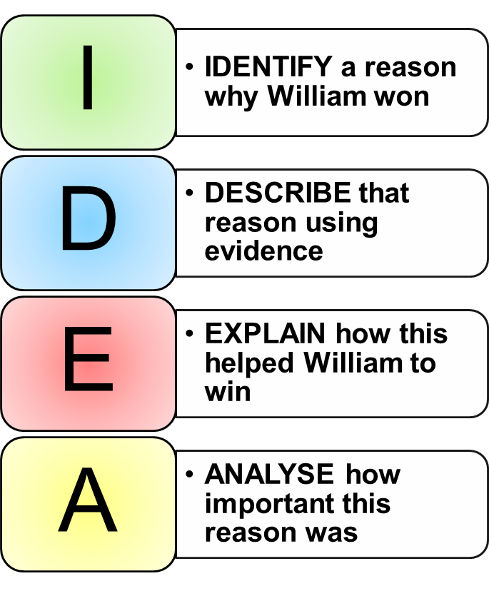
- Using your historical knowledge (LO6)
  - TIP: Make sure you know what happened at the Battle & can give specific examples.
- Explaining why things happened (LO1)
  - TIP: Remember that there are many different reasons or causes for William winning the battle – try to find the connections between them, or explain why some are more important than others.
- Writing in a clear way (LO6)
  - TIP: Remember to write in paragraphs, have an introduction which gives the background to the battle, and a conclusion which explains your overall opinion. Use the IDEA structure to help you structure your paragraphs.

Word Bank | Sentence starters
battle  cavalry  Harold Godwinson  Housecarls  leadership  Senlac Hill  William of Normandy | The Battle of Hastings happened in… when…  This essay will explain why…  There are many reasons why…  One reason that William won at Hastings is…  For example he…  …helped him win because…  If this had not happened…  Another reason why William defeated Harold…  If it had not been for…  The most important reason for William’s victory…  …is the most important reason because…  This links to…

History Common Assessment Feedback
Title: Why did William Win the Battle of Hastings?
This assessment was testing your ability to do all of the things below. Your teacher will have given you a mark depending on how well they think you did at each of these. Use this to help set yourself targets for next time.

Your Knowledge of the Battle of Hastings (LO6)
Limited | 0-100pts | You make limited reference to specific details or you use details in a generic way. You have no real knowledge of specific actions or events which led to William’s victory. There may be inaccuracies in your knowledge.
Beginning | 200pts | You have shown some knowledge of the tactics used by William or the failures of Harold. You may refer to things they did but in generalised ways – you are generally accurate however. There may be some inaccuracies in your knowledge.
Sound | 300-400pts | You show that you understand more than one of the following: William’s specific tactics, Harold’s mistakes, the context leading to the battle.
Secure | 500-600pts | You have shown a clear understanding of: William’s specific tactics, Harold’s mistakes, and the context leading to the battle. You give specific evidence for all of these, helping to write a convincing answer.
Your Writing (LO6)
Limited | 0-100pts | You have written briefly about some relevant things and have described some of the information you have found out.
Beginning | 200-300pts | You have clearly tried to answer the question. Your answer is mostly a description of events but uses some good knowledge. You don’t explain how your evidence links back to the question.
Sound | 400-500pts | You have used paragraphs to structure your answer and you have chosen key factors to write about. You use some evidence to back up the points you make in each paragraph. You have made links back to the question in the majority of your paragraphs and there is a developing PEEL/IDEA structure evident.
Secure | 600pts | You have written a clearly analytical piece based on key factors. You have used evidence to back up your points clearly and you have very clear links back to the question. The PEEL/IDEA structure is used very well. In particular, you make clear links back to the question in each paragraph.
Explaining Why Things Happened (LO1)
Limited | 0pts | You have not really explained why William won the Battle.
Beginning | 100-200pts | You have identified some reasons why William won the Battle of Hastings but not always clearly explained how these helped him win.
Sound | 300-400pts | You have identified at least 3 reasons why William won the Battle of Hastings and shown how these helped him to win
Secure | 500pts | You have identified at least 3 different reasons why William won the Battle of Hasting and have shown how these link together to lead to William’s victory
Explaining the Importance of Different Causes (LO1)
Limited | 0pts | You have not really shown that some causes had more importance than others in William defeating Harold.
Beginning | 100pts | You have shown that some causes were more important in William winning but not really supported this with evidence or explained fully.
Sound | 200pts | You have explained why at least one factor was more important than others in helping William to win.
Secure | 300pts | You have clearly explained the importance of different factors which led William to beat Harold at Hastings.

Summary
Success | Challenge

Points Earned | Effort | Progress
 |  | - = +

Student Comment
In your own words try to explain why you got the mark you did…

In your own words, what target will you set yourself to improve your work for next time?

Teacher Notes
The table below shows how the points achieved by the student will translate into expectations for this Year 7 task. These grades should be recorded in your mark book but not shared with the student
0-500pts | (B) Working Below expectations for Year 7
A minority of students | Students at this level will tend to produce work which contains limited knowledge of the actions of William or of the events leading up to or during the Battle. Knowledge will be asserted where available and there may be inaccuracies in the knowledge given. In other cases, the knowledge used may be generic rather than specific eg. William played a trick on Harold…  The structure will tend to be narrative. Command of language will be weak.
600-900pts | (W) Working towards expectations for Year 7
Some students | Students at this level will show at least some knowledge of actions taken during the Battle of Hastings. Students may well give descriptions of the actions of William or the failures of Harold with some supporting detail. Knowledge will be relevant and accurate for the most part. They may also show some outline knowledge of the context of the battle.  The structure will still tend towards narrative, although some paragraphing may be evident thanks to the planning frame. Links back to the question will be implicit at best. There will be some evidence that the student understands at least the main outlines of the Battle of Hastings.
1000-1300pts | (E) Meeting expectations for Year 7
The vast majority of students | Students at this level will have a good understanding of the main events of the battle including some specific detail on the actions of William and of other factors leading to the victory. Evidence will be chosen to answer the question and there will be signs that there is a rationale to the choice of evidence. The accuracy of evidence will be generally good. There may be a stronger sense that students understand the context of the battle.  There will be a logical structure to the work, with key topics forming paragraphs and some conclusion, even if only short, being arrived at. The explanations given in paragraphs may still be implicit in their links to the question, however the conclusion will make an attempt to provide a direct answer to the question. Command of language will be adequate.
1400-1500pts | (A) Working above expectations for Year 7
A minority of students | Students at this level will tend to show a very good understanding of the battle – including specific details of the different contributing factors to William’s victory. There will be a rationale evident for the choice of evidence which will be deployed in a way which helps their argument. Analysis of this evidence may still lack depth however there will be obvious attempts to use the evidence to directly answer the question.  The structure of the essay will be largely analytical with a focus on the question which is sustained for the majority of the time. The account will show a deliberate engagement with the question and the conclusion will show an independent reflection on the question itself. At this level, students may also begin to consider the impact of different causes and see links between them. Command of language will be good.
1600-2000pts | (A+) Working well above expectations for Year 7
Exceptionally rare | Student at this level produce a sustained and well-focused answer which is analytical. The answer will use a range of specific and accurate evidence to explore the importance of different factors in leading to William’s victory. There may still be some limitations to the analysis but the conclusions will demonstrate clear, justifiable and independent thinking and a good command of language.
Please ensure:
- You make a note of the points, grade and effort in your own mark book
- The student sticks in the marking proforma
- The student responds to the comments and corrections
- The student adds their points to their totaliser which is in the back of their book

Knowledge (LO 6.1)
Limited | 0-100pts | Students make limited reference to specific details or use details in a generic way. There is no real knowledge shown of specific actions or events which led to William’s victory. There may be some inaccuracies in knowledge which is used. | B
Beginning | 200pts | Students demonstrate some knowledge of the tactics used by William or the failures of Harold. They may refer to things they did in generalised ways rather than being specific. There may still be some inaccuracies in the knowledge used. | W
Sound | 300-400pts | Students show specific knowledge and understanding of one or more of the following: William’s specific tactics, Harold’s mistakes, the context leading to the battle. | E
Secure | 500-600pts | Students show a sound understanding of the main areas: William’s specific tactics, Harold’s mistakes, and the context leading to the battle. They give specific evidence which shows signs of selection. The evidence helps to create a convincing answer. | A
Argument and Communication (LO 6.2 & LO 6.3)
Limited | 100pts | Students make an effort to answer the question set by writing about at least some relevant information. The structure here will probably be a simple narrative covering what happened in some part of the battle. | B
Beginning | 200-300pts | There is evidence that students have tried to answer the question set. They generally describe the events of the battle but they do this using relevant knowledge. At the bottom of the level there might be little attempt to provide a structure. At the top of the level students might attempt to group their ideas more clearly | B/W
Sound | 400-500pts | Students use paragraphs to structure their thinking. They support their argument with evidence. At the bottom of the level, students might leave the links to the question fairly implicit, however there will be some explanation of the reasons why William won, even if this is only at the end. At the top of the level, students show evidence of a PEEL/IDEA structure with links back to the question being made. | E/A
Secure | 600pts | Student produce an analytical piece based around the key factors leading to William’s victory. They use a good range of evidence to back up their points, showing a good command of the topic. They explain their evidence and make links back to the question. The PEEL/IDEA structure is used well. | A
Making Causal Webs (LO 1.1)
Limited | 0pts | There is no real explanation offered of why William won the Battle either in the main body or in conclusion. | B
Beginning | 100-200pts | Students identify some reasons why William won the Battle of Hastings though the links between these and his victory are only partially explained or left implicit. A narrative with implied causation would fit in this band. | W/E
Sound | 300-400pts | Students identify at least 3 reasons why William won the Battle of Hastings and explain how at least two of these led to his victory. Explanations make a link back to the question. At the top of the level the analysis is clear and leads towards a conclusion. | E/A
Secure | 500pts | Students identify and explain at least 3 different reasons why William won the Battle of Hasting. They show how these link together to explain William’s victory | A
Ranking the Influence of Causes (LO 1.2)
Limited | 0pts | Students make no real reference to the importance of different causes that some causes had more importance than others in William defeating Harold. | B/W
Beginning | 100pts | Student make some reference to the importance of different causes in William’s victory. The judgement will not be fully supported or explained. | E
Sound | 200pts | Students explain why at least one factor was more important than others in William’s victory. | A
Secure | 300pts | Students show clear independent thought and judgement in considering the different causes of William’s victory. They show the importance of each factor in leading to William’s victory and appreciate the interconnected nature of causes. | A

