American West: Bibliography
The following are just a few recommendations to expand your knowledge (and love) of the American West. If you feel you have read or seen something worth adding then please let me know. Mr F

Overview Books
I have classified the following books as “overview books” because I think that they work best to give broad topic overviews. These are the kinds of books you might want to read cover to cover. I have tended to only include books which are accessible and easy to read on this list.
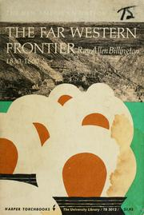 | Ray Allen Billington: The Far Western Frontier 1830 1860 (Harper, 1962).  For a very readable if very traditional account of the far West. Lots of tales of intrepid white settlers moving across the continent in a Turnerian mode. Actually a very good (if skewed) read.
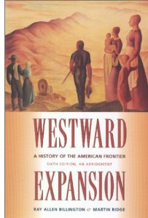 | Ray Allen Billington and Martin Ridge: Western Expansion: A History of the American Frontier (Macmillan, 1957).  As above but this time covering the frontier process more generally. Notable by the fact that it is still in print!!
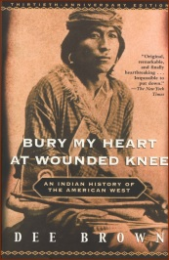 | Dee Brown: Bury my Heart at Wounded Knee (Holt, Rinehart & Winston, 1970)  Riddled with historical issues and problems but I really cannot recommend this book highly enough. An attempt to tell the story of the American West from the perspective of the Native Americans. Well written, accessible with a clear narrative. At times this makes a harrowing read but it shows an historian taking a very definite approach to tell the story of Native Americans through their words, or as Brown puts it “looking Eastward”. A must read!
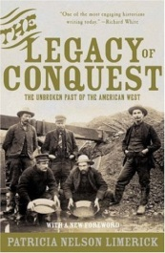 | Patricia Nelson Limerick: The Legacy of Conquest: The Unbroken Past of the American West (Norton, 1988).  One of the books that helped create the New Western History – focuses on retelling the story of the West without reference to the frontier of Turner
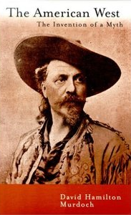 | David Murdoch: The American West: the Invention of a Myth (University of Nevada Press, 2001)  An excellent book detailing how the myth of the American West has been created and used. A very readable, sinister portrait of the calculated use of the American West by C19th and C20th century politicians as a tool to distract people from the growing nightmare of the American dream!

Depth Books
These books are more specifically targeted at particular areas of the American West. They vary in accessibility but I have tried to comment on this after each recommendation. You might use these books to dip in and out of to get some more specific details or deepen your understanding
William Cronon, George Miles and Jay Gitlin: Under an Open Sky: Rethinking America's Western Past (Norton, 1993).
NOT YET RATED
One of the books that helped create The New Western History

Mark S Joy: American Expansionism, 1783-1860: A Manifest Destiny? (Longman, Seminar Studies in History, 2003)
NOT YET RATED

Patrica Limerick, Clyde A Milner II and Charles E Rankin (eds): Trails: Towards a New Western History (University Press of Kansas, 1991).

A great collection of essays on a whole range of subjects connected to the American West. Really easy to dip into although you will probably want to refer to other works to make sense of some of the content. Reads a bit like a defence of the New Western History

Clyde A Milner, Carol A O'Connor, Martha A Sandweiss (eds): The Oxford History of the American West (OUP 1994).

Huge book – available in the library. Some good essays on a wide range of subjects though it does not fall neatly into a category of Western history and can be a bit dry in places. Very comprehensive though

Clyde A Milner (ed): A New Significance: Re-Envisioning the History of the American West (OUP 1996)
NOT YET RATED

Francis Parkman: The Oregon Trial (1849)

Parkman’s own account of his travels with the Oglala Sioux. A good example of the early romantic versions of the West. It is available in many modern editions and makes some interesting reading. Parkman’s attitudes to the West are especially interesting – he sees it as a savage wilderness but with redeeming properties at the same time. Fascinating portrayal of natives whom he sees in the same terms.

Frederick Jackson Turner: The Frontier in American History, (Dover, 1996).

Contains two crucial essays: 'The Significance of the Frontier in American History', and 'Contributions of the West to American Democracy'. The first essay has been republished by Penguin in their Great Ideas series. The whole text is available here: http://xroads.virginia.edu/~hyper/turner/

Margaret Walsh: The American Frontier Revisited (Macmillan 1981)
NOT YET RATED

Richard White: It's Your Misfortune and None of My Own: A New History of the American West (University of Oklahoma Press, 1993)

A classic telling of the New Western History. Could almost be on the list of overview books and might be interchangeable for Limerick’s effort. White is a very accessible writer and I enjoyed this book immensely.

Articles & Websites
A range of articles are available on the Harrogate History website which you can find at http://harrogatehistory.weebly.com More articles are added on a regular basis so don’t forget to keep checking back.
- www.timelines.tv – this site has a fantastic basic overview of the American West and is really easy to use.
- http://kclibrary.lonestar.edu/decade00.html - want to know more about what was happening when people were writing their histories? What was playing in the cinema when Billington wrote his books? This site gives a decade by decade overview of important events of the C20th in America. Gives the major socio-economic and political changes
- http://www.pbs.org/weta/thewest/program/ - website which goes with Ken Burns’ (Steven Ives’) documentary on the American West – loads of primary source materials and links
- http://west.stanford.edu/ - The Bill Lane Centre has a few interesting links – site is a bit dry though
- http://theautry.org/ - The Autry museum has a huge range of links to educational resources plus an excellent section on women in the West and the myth of the cowboy. Also has its own YouTube channel
- http://collections.theautry.org/mwebcgi/mweb.exe?request=ks – access to a whole host of primary sources from the Autry online archive

Films
Films provide a rich seam of information to learn about interpretations of the West. Again you need to be careful about how you use films as interpretations of the past but certainly they show a lot about contemporary attitudes to the West. Most cowboy films are worth a bit of a watch but here are some special ones I have pulled out.
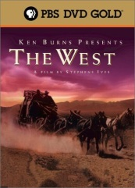 | Ken Burns’: The West (1996)  “It's a landscape that has to be seen to be believed. And as I say on occasion, it may have to be believed in order to be seen.” N. Scott Momaday. The result of a five year investigation and filming mission into the archives of the American West. Bringing together the standard histories with literature and oral histories this documentary aims to bring an element of the New Western to the documentary genre. Eight fantastic episodes look at the stories of the people who made the West in an attempt to break the frontier mould. Brings in contributions from Patty Limerick and Richard White. Fantastic!!
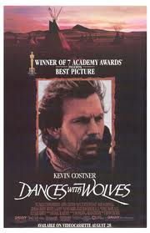 | Kevin Costner: Dances with Wolves (1990)  NOT YET RATED  Dances with wolves tells the story of an army officer who befriends a Native American tribe and becomes one of them. Revitalised the Western film industry and was widely credited for doing for film what Dee Brown did for historical books. Watch out for the Jesus complex storyline however.
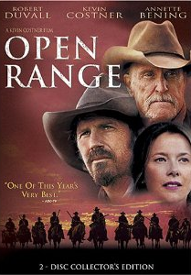 | Kevin Costner: Open Range (2003)  A story about the ending of the open range – watch how the corrupt business interests of the East taint the purity of the Western way of life.
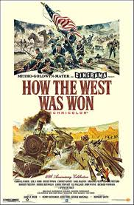 | John Ford: How the West was Won (1962)  “A family saga covering several decades of Westward expansion in the nineteenth century--including the Gold Rush, the Civil War, and the building of the railroads.” A real all-star cast and the archetype for the Old Western evolutionary frontiersman story. Tells the story of the West for the whole of our period including the winning of the land “from primitive nature and primitive man”
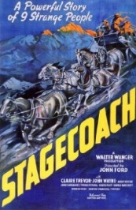 | John Ford: Stagecoach (1939)  “A group of people traveling on a stagecoach find their journey complicated by the threat of Geronimo and learn something about each other in the process.” One of John Ford and John Wayne’s earliest collaborations. Couldn’t be more Old Western if it tried. Incidentally Geronimo’s “army” of marauding Indians was only ever a band of 24 refugees fleeing from imprisonment without trial… still to the victor the spoils eh?
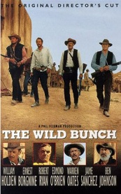 | Sam Peckinpah: The Wild Bunch (1969)  NOT YET RATED  “Outlaws on the Mexican-U.S. frontier face the march of progress, the Mexican army and a gang of bounty hunters led by a former member while they plan a robbery of a U.S. army train. No one is innocent in this gritty tale of desperation against changing times. A classic tale of the gun slinging West”
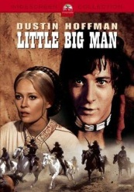 | Arthur Penn: Little Big Man (1970)  NOT YET RATED  “Jack Crabb is about 100 years old as the film begins. A collector of oral histories asks him about his past. He recounts being captured and raised by Indians, becoming a gunslinger, marrying an Indian, watching her killed by General George Armstrong Custer, and becoming a scout for him at Little Big Horn.”
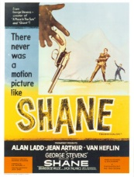 | George Stevens: Shane (1953)  NOT YET RATED  Tells the story of the conflict of interests between the cattle barons and the simple homesteaders. An interesting portrayal of plains life and voted 45th best film of all time.

