A Ford
Harrogate Grammar School
5/16/2011
An Introduction to F983/4: Using Historical Evidence

Table of Contents
Introduction 3
The Exam 3
Understanding and skills developed 3
How do I use sources? 3
Types of sources and associated issues 4
Contemporary commentaries and histories 7
Memoirs 8
Diplomatic records 9
Business records 10
Church records 11
Works of art etc. 11
Statistics 13
Historians’ opinions 14
Humanist writings 15
Scientific writings 16
Diagrams 17
Using sources critically 18
Drawing inferences from sources 18
Analysing sources for part a 20
Analysing sources for part b 21
Revision checklist 22
Exam Guidance 23
Generic Mark Schemes Appendix A

Introduction
This booklet is here to support you in your Using Evidence paper on the Italian Renaissance. Please make sure you use this throughout the year as a reference, and in planning and revising for your exams.

The Exam
The exam is 1 ½ hours and is split into two main parts. Part A asks you to critically use a set of seven sources to test and amend a given interpretation (eg. The main concern of Renaissance rulers was warfare and conquest). Part B asks you to examine the utility of these same sources in their own right. There is detailed guidance on the exam later.

Understanding and Skills Developed at A/S:
You will be developing a number of core areas during your AS Level studies. These will combine to support your continued study of History at A2. The skills of source analysis and explanation will become a key part of your personal study next year, and an understanding of interpretations will help you better access the American West course. Areas you will develop this year include

- Understanding the wide range of different types of historical sources – eg written, pictorial, statistical – and the different issues they raise as well as the different uses they have;
- Understanding that historical sources do not speak for themselves, they have to be interpreted;
- Appreciating that historical sources do not have a fixed and unalterable meaning – they can be interpreted in many different ways;
- Understanding that interpretations of historical sources must be based on, and consistent with, the content of those sources, and with their historical contexts;
- The importance of the questions asked about historical sources;
- The importance of the purposes, interests and the intended audiences of the authors of historical sources;
- Using historical sources together and cross-referencing between them;
- Understanding how and why different interpretations of the past are constructed;
- Understanding how interpretations of the past can be amended in the light of evidence;
- Using historical sources to test the validity of interpretations.

So... How Exactly Do I Use Sources?
The use of sources is the main focus for the F983/4 paper. This unit will focus on the study of a topic that covers approximately a hundred years; and will involve exploring issues relating to the use of historical sources and interpretations. Unlike at GCSE you will be required to use a range of historical sources together, in context and as evidence, to evaluate and possibly amend an interpretation.

Types of Sources and Associated Issues
You will encounter a wide range of sources in this unit. Some examples of these are given in this booklet.

 | Egs. | Useful for… | Issues…
Contemporary commentaries and histories | “On the Florentine Republic” Bruni 1439 (Florence)  “Lives of the Most Excellent Painters, Sculptors and Architects” Vasari 1568 (Florence)  Sermons by Savonarola 1494-8 (Florence)  “A History of Italy” Guicciardini 1561(Florence)
Memoirs | Personal writings of the richer sectors of society such as Rucellai or the Medici. Diary keeping is a growing phenomenon in the Renaissance  Personal writings of Popes such as Pius II
Diplomatic records and letters | Letters between important figures. Especially between artists and their patrons.  Diplomatic records sent back by envoys. Florentine and Venetian envoys tended to have short contracts but other served for very long periods of time in their adopted cities.
Records from businesses, including contracts | Records of sales and incomes in major businesses.  Examples of contracts, particularly for the production of major works by craftsmen and artists.
Church records, including those of confraternities | Records of church taxation  Papal Bulls (announcements and commands made by the Church)  Records from the constitutions of confraternities setting out their aims and purposes.
Works of art or sculpture | Examples taken from proto, early and high Renaissance. Mannerist art.  Giotto, Raphael, Botticelli, Da Vinci, Michelangelo, Titian, Bellini, Ghilberti, Donatello, Fra Angelico, Masaccio
Works of architecture | Examples taken from proto, early and high Renaissance. Mannerist period.  Brunelleschi’s Ospitale della Innocenti and the Dome on the Santa Maria del Fiore.  Alberti’s Palazzo Rucellai  Ghilberti’s Baptistry doors  The competition to redesign St Peter’s under Julius II
Statistics | Catasto – Tax records from 1427 and later  Other tax and wealth statistics
Historical opinions | Traditional views such as those of Burckhardt which suggest a large change between Middle Ages and Renaissance,  Revisionist views which suggest that there was more continuity.
Humanist writings | “Oration on the Dignity of Man” Mirandola 1486  “Discourses on Livy” Machiavelli 1519 (Florence)  “The Prince” Machiavelli 1513 (Florence)
Scientific writings | “The Fabric of the Human Body” Andreas Vesalius 1543  “On the Revolutions of the Heavenly Spheres” Copernicus 1543  “On Medical Reform” Paracelsus 1530
Diagrams etc. | Leonardo’s sketches  Medical and scientific diagrams by people such as Copernicus or Vesalius

Contemporary commentaries and histories

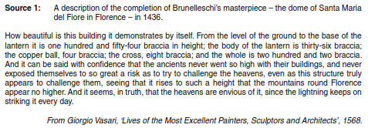
Source 1
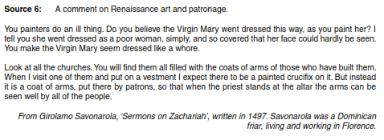
Source 2
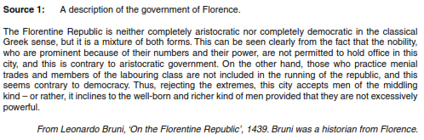
Source 3
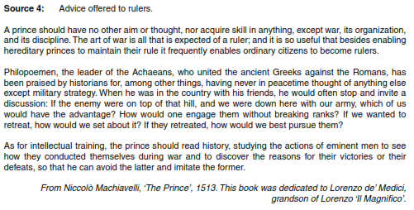
Source 4

Memoirs
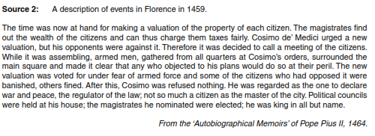
Source 5
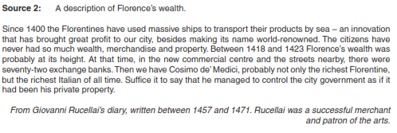
Source 6
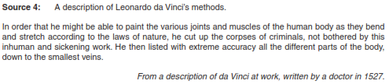
Source 7
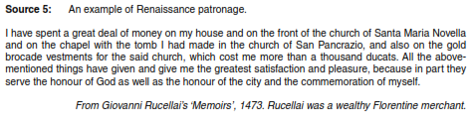
Source 8

Diplomatic records and letters

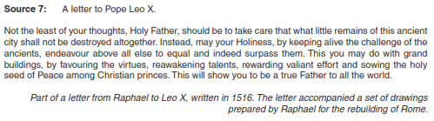
Source 9

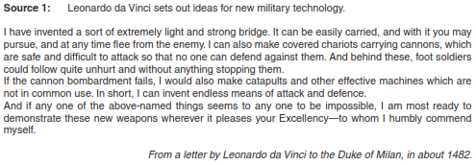
Source 10

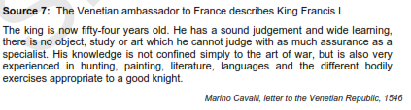
Source 11
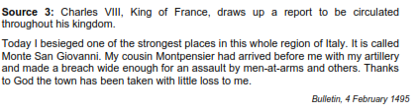
Source 13
Source 12
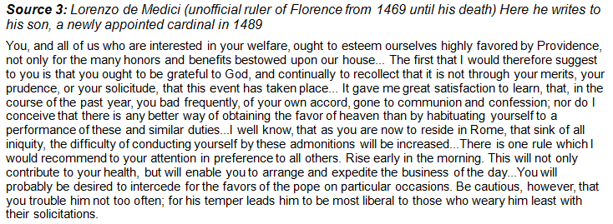

Records from businesses, including contracts

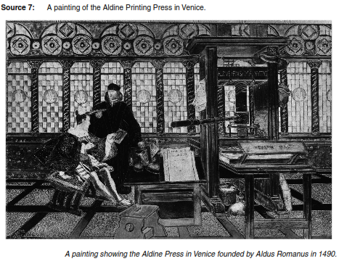
Source 14
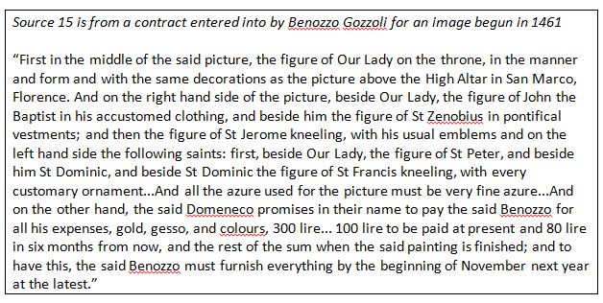

Church records, including those of confraternities

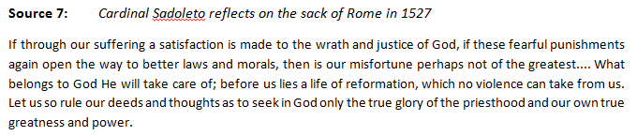
Source 16
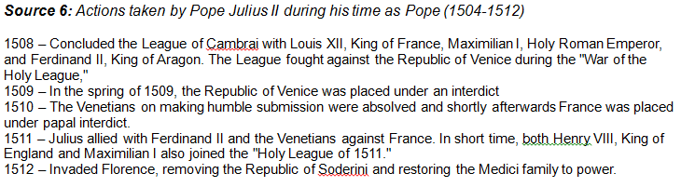
Source 17
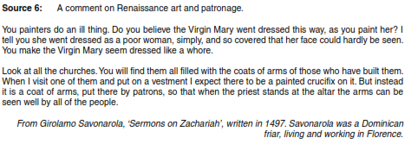
Source 18

Works of art, architecture or sculpture
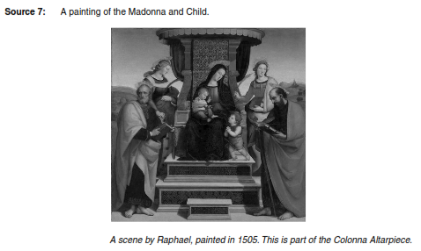
Source 19
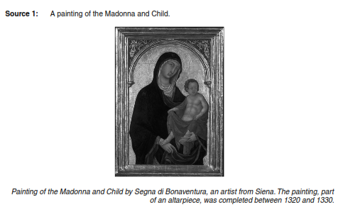
Source 20

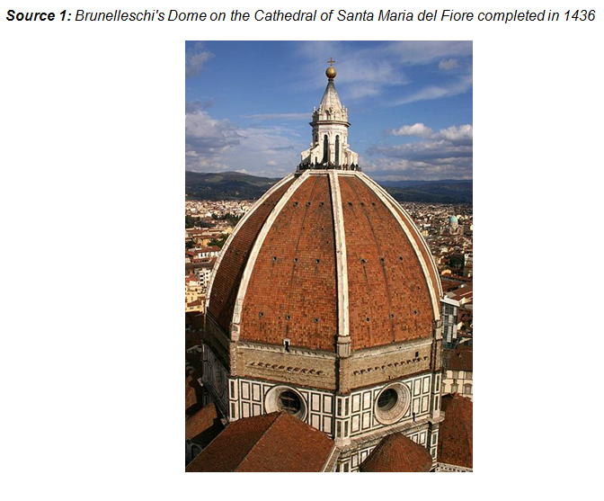
Source 21
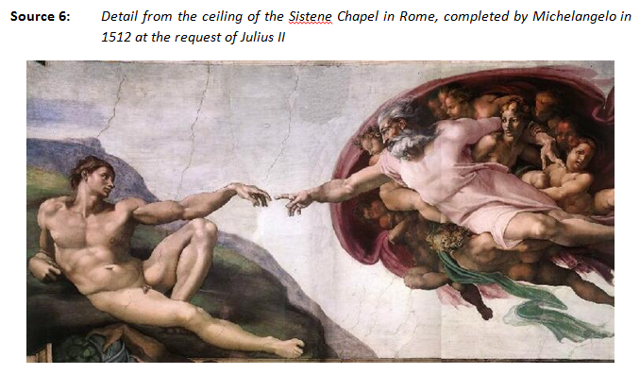
Source 22

Statistics

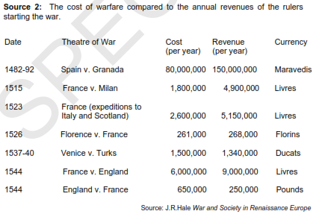
Source 23
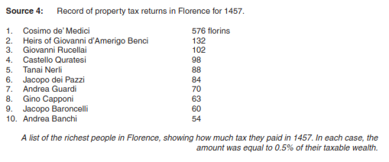
Source 24

Historical opinions

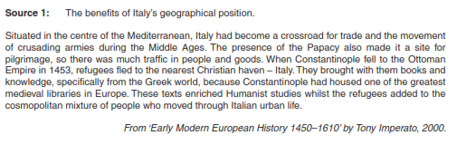
Source 25
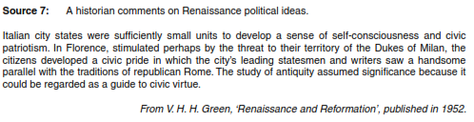
Source 26
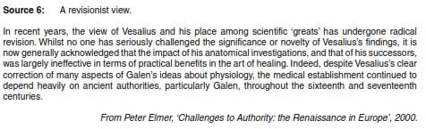
Source 27
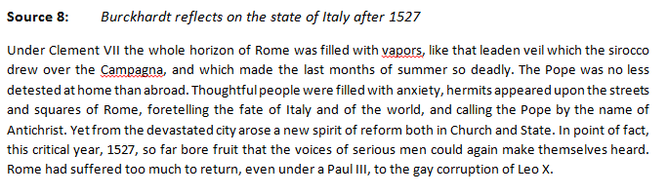
Source 28

Humanist writings

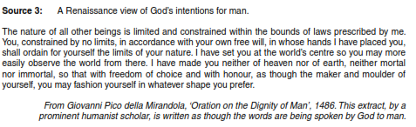
Source 29
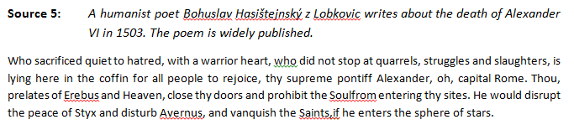
Source 30
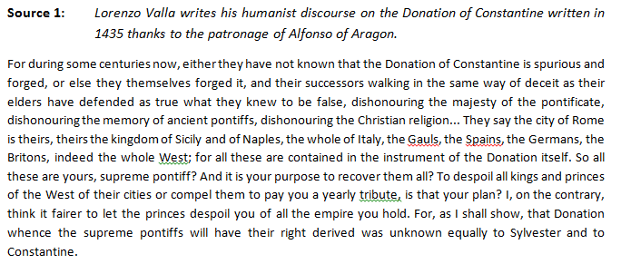
Source 31
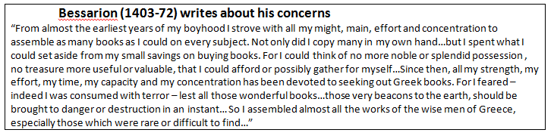
Source 32

Scientific writings

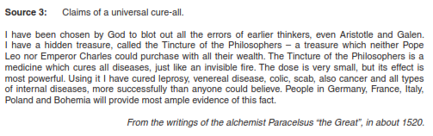
Source 33

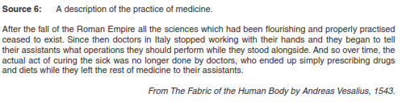
Source 34

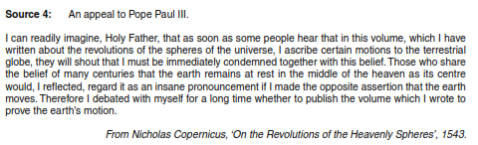
Source 35

Diagrams etc.

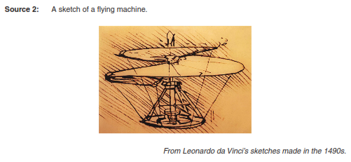
Source 36

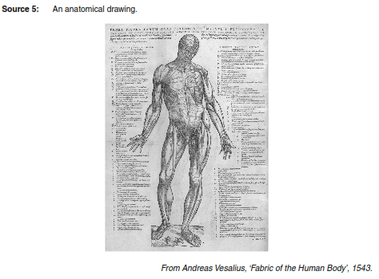
Source 37

Using Sources Critically
It is good when using sources to remember some basics:
Who - Who made the source - did they have an opinion or particular perspective? Were they involved?
What - What information does the source give? Is it the full story? Is it accurate?
Why - Why was the source made? Was it made to persuade people of a particular opinion? Was it made to take the mickey out of something/someone?
When - Was it made at the time? Or years later? Was the person there? Does it matter?
Where - Where was the source made? Were they involved in the event? Did they have an opinion?

Interpreting & Drawing Inferences from Sources at A level
For both written and image sources, it is unlikely you will be able to answer all of the questions above. However, you should try to address the basic areas of analysis: author, audience, perspective, purpose, context, motivation and validity. The who, what where, when, why and how of it all. Below are specific questions to help you analyze the sources to evaluate their utility in building an argument.

Written Sources
Identify the source. Is it primary or secondary? Who wrote it? When was it written? What kind of document is it? Where was it published? How widely was it circulated? What is it about?
Put it in its context. What events had happened or were happening when this was written? Specifically, what was happening where this was written? Who was the intended audience and what bias might they have had?
Consider the author and their purpose. Who was the author? Consider their race, gender, religion, nationality, heritage, party affiliation, socio-economic class, and their job. Is there bias? Is the author trying to persuade, incite, enlighten, explain or deceive their audience? Why was it written and for whom? Was the author paid to write this? Or bribed or threatened? Where did it first appear: a newspaper, a diary, a letter or a propaganda flyer?
Evaluate the information. Read the information, summarize it, and identify keywords, examples of bias and intention. Are there footnotes or citations? Does it reference other documents or events? What is the document about and how does that help you understand the period? What is the overall theme? How similar is it to other documents from the same period? How does the author claim to have their information? What assumptions does the author make? Is the author expecting any resulting action, sentiment or opinion from the audience?

Image Sources
Identify the source. Was the artist an eyewitness or is this image secondary? Who created it? When was it created? What medium is it? What is it portraying? Where was it published? Who would have seen this image?
Put it in its context. What events had happened or were happening when this was created? Specifically, what was happening where this was created? How long after the actual event portrayed was the image created? Who was the intended audience and what bias might they have had?
Consider the artist/creator and their purpose. Who was the artist? Consider their race, gender, religion, nationality, heritage, political point of view, socio-economic class, and their job. Is there bias? Are certain people or places portrayed in a more positive light? Is the artist trying to persuade, incite, explain to or deceive their audience? Why was this image created and for whom? Was the artist paid to do his work? Or bribed or threatened? What does that tell you? Where did it first appear: a newspaper, a diary, a letter or a propaganda flyer?
Evaluate the information. Look at the image, understand what is being portrayed, and identify the main focus and points of interest. Is there a caption or a title? Is it captured in a particular style? If yes, what associations can you make with this style? What does the scenery, the action, the people and the details tell you about this period in time? What is the overall theme? How similar is it to other images from the same period? If it is unusual for its period, why might the artist have chosen to be different? What assumptions does the author make? Is the author expecting any resulting action, feeling or opinion from the audience?
Remember... you are being tested on your ability to analyse sources. You won't be expected to know minor details of the architecture in a photo and you won't necessarily know the class and religion of an author. Use the information you are given in the source, recognize and detect in the source. Your own knowledge of the period of time should add to the source evidence you have before you in answering a question.

Using Sources to Test an Interpretation
The F983/4 paper asks you to use sources to test a given interpretation. The skill is in showing how the original might be supported but also using the sources to suggest an improved alternative.

It is possible that interpretations might be very general. In this case you should be looking to identify change over time. Key words to look out for or use are: turning-point, false dawn, trend, continuity and discontinuity. For example you might get the following interpretation:

“The influence of the Church declined over the Renaissance”

From reading the sources you are given, it might be better to suggest that whilst this was true in the early Renaissance, 1494 represented a turning point and thereafter the influence of the Church increased.

Analysing Sources for Part A
In part A you will be using sources to test and amend an interpretation. Drawing sophisticated inferences from the sources will be important (ie. Reading deeper into them) You will need to be aware of the weight of evidence provided by a source given its provenance. Cross referencing will be vital to supporting or challenging the interpretation

Obvious message |  | Inferences
Issues of provenance
 | Adds to weight |  | Detracts from Weight
Date created & Historical Context
Type of source
Comparison to own knowledge (Validity)
Language Used
Author – Purpose & Audience
Typicality

Analysing Sources for Part B
In part B you will be asked to show how the sources might be useful or limited for investigating the WHOLE TOPIC ie. The entire Renaissance. You need to establish how the sources might be used to find out about a topic. Each source may give detail on a range of issues (some better than others). You also need to consider how the provenance limits the utility of your sources for their chosen purpose.

What can the source can tell me about? Think of questions this might provide the answer to. It may have several uses and be more useful for some applications than others.
Issues of provenance
 | Adds to utility for this purpose because... | Detracts from utility for this purpose because...
Date created & Historical Context
Type of source
Comparison to own knowledge (Validity)
Language Used
Author – Purpose & Audience
Typicality

The Italian Renaissance Content Revision Checklist
TOPIC | CONTENT | R | A | G
What is the Renaissance? | The meaning of the term 'Renaissance'
 | Background to Italy in the 1300s
 | The conditions in Italy in the mid-15th century, particularly North Italy and the city states including Florence
What were the causes of the Renaissance? | Growth of cities – mercantile culture and explosions in town growth. In particular town governance and financing.
 | Expansion of trade – creation of Florentine and other cities’ influence in the sphere of trade.
 | Role of individual genius
 | Rise of rich powerful capitalist patrons
 | Technical progress (including printing) – rise of libraries, centralisation of knowledge, distribution of political and philosophical thinking.
 | Malaise of the Church
 | the importance of the role of money, patrons including the Medici, and corporate (civic) pride and identity
How far was the Renaissance a break with the Middle Ages? | Break and continuities in terms of artwork ie. Proto Renaissance of Giotto etc.
 | Break and continuities in terms of the role of the Church
 | Break and continuities in terms of political organisation – ie continued Republic of Venice or break from feudal to Republican Milan
 | Break and continuities in terms of artwork ie. Proto Renaissance of Giotto etc.
What were the main developments in art, architecture and sculpture? | The main characteristics, innovations and achievements in architecture, painting and sculpture;
 | Main artists and styles of the Early Renaissance – focus on Florence and the works of Brunelleschi, Ghiberti, Fra Angelico, Donatello, Botticelli etc.
 | Main artists and styles of the High Renaissance – focus on the move to Rome. Michelangelo, da Vinci, Raphael etc.
 | Main artists and styles of the Mannerist period
 | The importance of Rome; the role of the Church in inspiring and purchasing Renaissance art; the religious motives of patrons; the poor and charitable confraternities
 | The significance of eg, Leonardo da Vinci, Raphael and Michelangelo
What were the main intellectual developments? | Humanism and the main humanist thinkers
 | Early humanism vs. Neoplatonism
 | Causes of the growth in humanism
 | The impact of humanism
What was the socio-economic framework of Renaissance Italy like? | The social structure of Renaissance cities ie. role of men, women and children
 | The economic structure of the Renaissance – key trading centres. Main trades etc.
 | The role of the guilds in the economic structure
 | The economic influence of Florence and Venice
How did politics develop during the Renaissance? | The political structure of Florence, Venice, Milan and Naples
 | developments in political thought and ideas including Machiavelli’s “The Prince” and Castiglione’s 'The Book of the Courtier'
What role did the Church play in the Renaissance? | The importance of Rome as a cultural and religious capital – look back to rise of Rome in this respect – Constantinian Donation
 | The role of the Church in inspiring and purchasing Renaissance art – famous Renaissance ie. Michelangelo
 | The religious motives of patrons in commissioning art – how far were people motivated by the secular and how far by the religious?
 | The poor and charitable confraternities – comparisons with English gilds – discussion of their role, function, constitution, membership and purpose. Especially look at doctrines of Purgatory and how this may have influenced religious outpouring.
What were the main developments in warfare? | Rivalries and warfare between the Italian states including the Peace of Lodi
 | The French Invasion of 1494 and the ensuing Italian Wars
 | The impact of the sack of Rome in 1527
 | the impact of war on society, economy, art and intellectual enquiry
 | The main technological developments in warfare
 | The role of mercenaries and their critics
What were the main developments in science and medicine? | The development of the scientific method and the main achievements in science and medicine – impact on society, return to Classical methodologies
 | The contribution of Leonardo da Vinci, Copernicus and Vesalius to this sphere
Comparative to Netherlands | the Renaissance in the Netherlands – Bosch, Brueghel and Vesalius
 | factors in the Netherlands that made it receptive, eg Van Eyck, trade links, patrons, intellectual developments.

